VisIT and SELFE plugin quick start

Installation
VisIT v2.4.0 installation
Please download the VisIT v2.4.0 windows x64 binary package from https://wci.llnl.gov/codes/visit/executables.html
Let’s assume you install in C:\Program Files\LLNL\VisIt 2.4.0
Install the SELFE plugin
Copy all the files in the visit_selfe_plugin_win64.zip to C:\Program Files\LLNL\VisIt 2.4.0\databases
Run the visit by going to Start >> All Programs >> Visit 2.4.0

Running the VisIT
Click on the Open icon as show below.
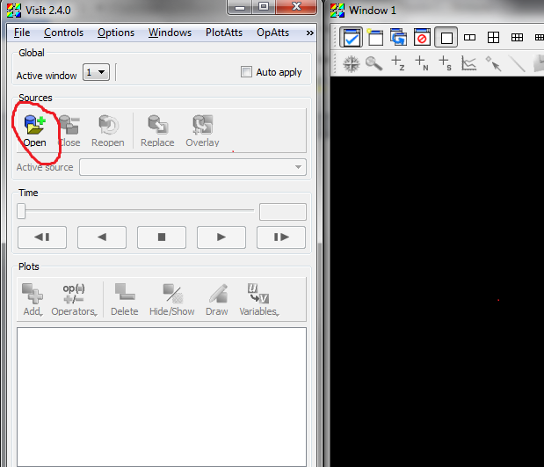
Specify the Path (directory) by typing the path, select the file / file grouping, and then set the open file as type to be SELFE.
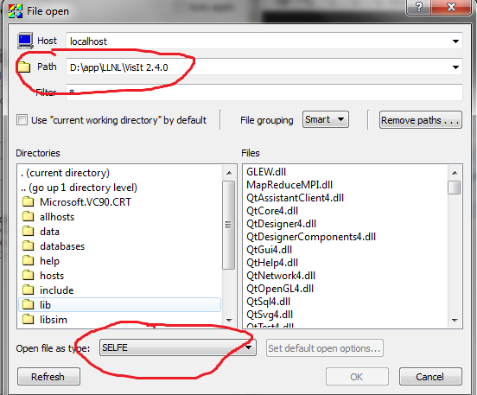

Plot the Mesh
Click on the Add icon, then select Mesh, choose either Bathymetry_Mesh or SELFE_mesh
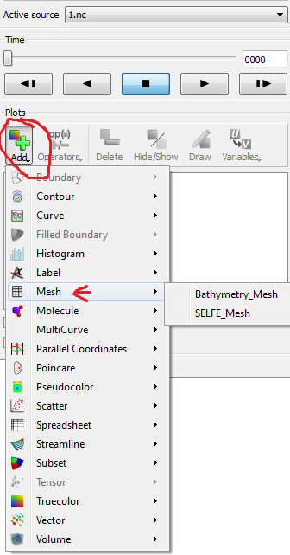

Plot Pseudoclor of variable
Similar to plot mesh, select Pseduocolor, then select the interested variables. For variable names in xxx_yyy pattern, those variable means the variable xxx in yyy layer, the layer numbering staring from 1, follow the same direction as your NetCDF.

Plot vector variable
You need define the vector variable before plotting, to define the vector, simple click on Controls in the menu bar, then select Expression….
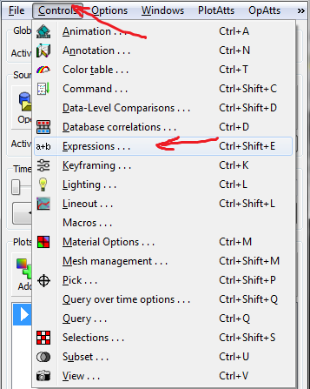
Then click New button in the opening window, enter the variable name to be sample_vector, the type to be Vector Mesh Variable, enter the definition as “{u_10,v_10}” (replace the scalar variable name u_10,v_10 to your own variable, {} means vector), click Dismiss, your new vector variable will be auto saved as you typing.
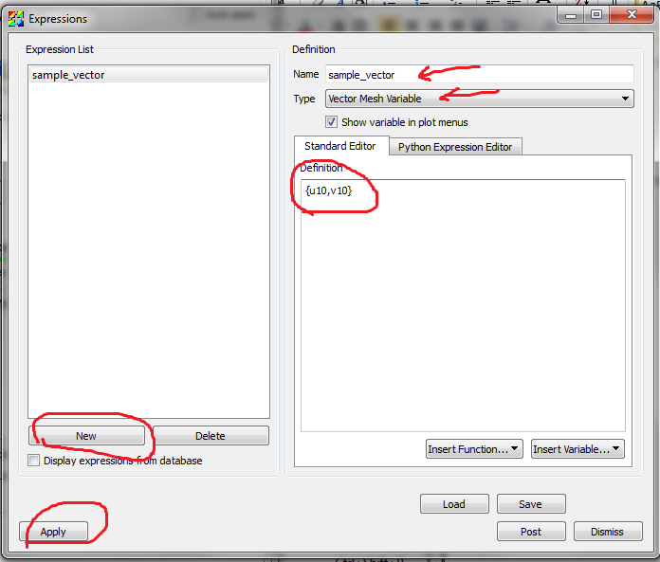
To plot, similar to mesh, click the Add, select Vector, then choose the sample_vector we just defined.
If you need to customize the vector plot, for example, increase number of plotings, simple click PlotAtts in the menu bar , then select Vector…, adjust the Vector Amount there.
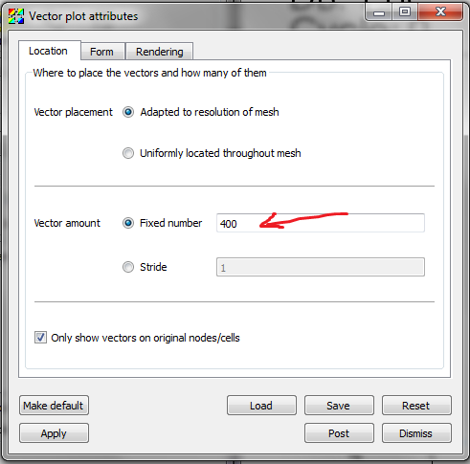
To learn more about VisIT, please go to https://wci.llnl.gov/codes/visit/doc.html

